Appendix 1
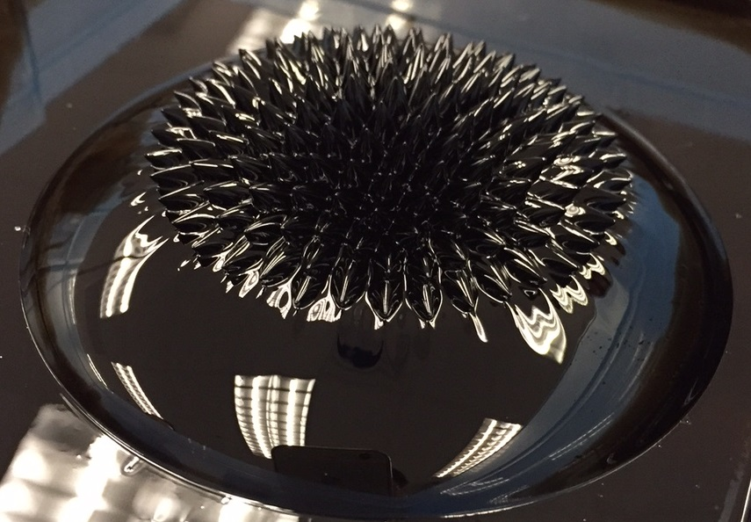  Ferrofluid exhibits its exotic behavior  under magnetic field. | 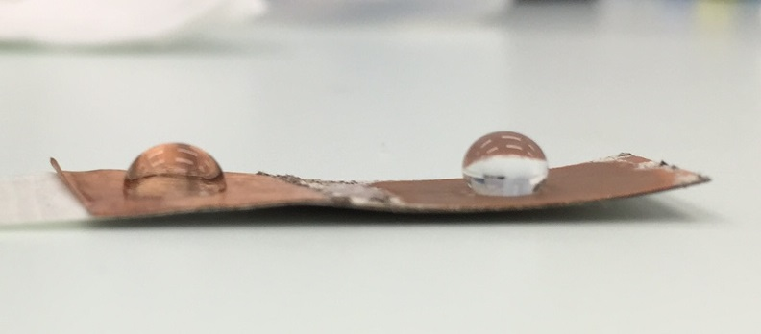  Water droplet becomes almost spherical  on a super-hydrophobic surface (right) in  comparison to a normal surface (left).
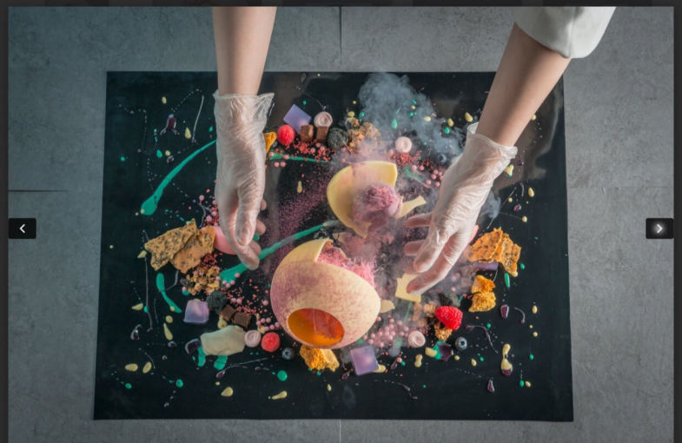  Demonstration by Sugar connoisseur from  Doux | 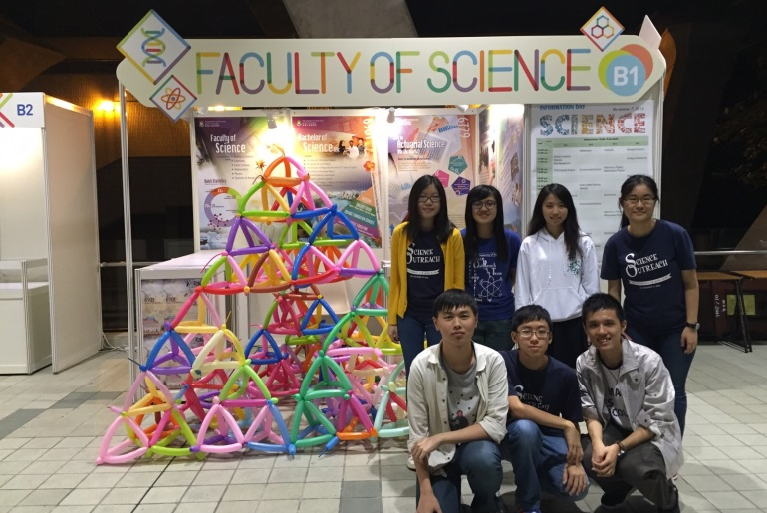  Miniature balloon fractal pyramid made  by HKU students

Appendix 2
Programme Rundown

Day 1 (January 16, 2016) @ HKU

Time | Events | Venue
08:30 – 09:00 | Registration | outside Hui Pun Hing Lecture Hall
09:00 – 09:15 | Opening Ceremony | Hui Pun Hing Lecture Hall
09:15 – 09:35 | Lecture 1: The Science of Ceramics | Hui Pun Hing Lecture Hall
09:35 – 09:55 | Lecture 2: Ferrofluid and Super-hydrophobic Surfaces | Hui Pun Hing Lecture Hall
09:55 – 10:15 | Group Photo Taking and Tea Break | Hui Pun Hing Lecture Hall
10:15 – 10:35 | Lecture 3: Art and Science of Sugar | Hui Pun Hing Lecture Hall
10:35 – 10:55 | Lecture 4: Secret Behind Pinhole Camera | Hui Pun Hing Lecture Hall
10:55 – 11:00 | Briefing on the Workshops | Hui Pun Hing Lecture Hall
11:00 – 12:30 | Parallel Workshops
 | Workshop 1A: Making Artistic Ceramics for Fun and Practical Use | Main Building 141
 | Workshop 1B: Liquid Magnet and Water-hating Super Coatings | Hui Oi Chow Science Building 207
 | Workshop 1C: The Sweet Adventure: Creating Your Own Sugar Art | Kadoorie Lab C and D
 | Workshop 1D: PinHoleCam-ology: a Moment of Hong Kong in a Box | Runme Shaw 302
12:30 – 14:00 | Lunch
14:00 – 17:30 | Parallel Workshops  (Continued) | Various venues
17:30 – 17:45 | Closing of Day 1 | Knowles Building 223

Day 2 (January 17, 2016) @ HKSTP Charles K.Kao Auditorium

Time | Events
08:30 – 09:00 | Registration
09:00 – 09:20 | Lecture 5: What is Fractal?
09:20 – 09:30 | Briefing on Workshop 2
09:30 – 12:00 | Workshop 2: Building the Largest Balloon Pyramid
12:00 – 13:30 | Lunch
13:30 – 16:30 | Workshop 2 Continued
16:30 – 17:30 | Closing Ceremony  Photo call - completion of the largest Fractal Balloon Pyramid  Media interviews with participants and organisers

