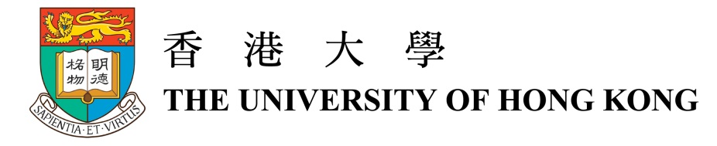

About University Museum and Art Gallery of the University of Hong Kong
The University Museum and Art Gallery (UMAG) of the University of Hong Kong was founded in 1953 as the Fung Ping Shan Museum. Originally established as the Fung Ping Shan Library of Chinese language publications in 1932 in honour of its benefactor, the building continues to run as a museum after the Fung Ping Shan library relocated into the University main library building in 1961. The museum was renamed the UMAG in 1994 shortly before its new wing was opened to the public in 1996. It is the oldest continuously-operated museum in Hong Kong and has over the past sixty years built up a diverse collection of ceramics and bronzes dating from the Neolithic period (c. 7000-c. 2100 BC) to the Qing dynasty (1644–1911), as well as traditional and modern paintings from the Ming dynasty (1368-1644) to the twenty-first century.
Chief among the collections are the Museum's ceramics, which show the extraordinary achievements of Chinese potters from Neolithic period painted pottery jars, to the decorative porcelains of the Qing dynasty. Among the early wares are examples of funerary vessels dating from the Han (206 BC–AD 220) to the Tang dynasties (618–907) that include lead-glazed models and objects, as well as tri-coloured (sancai) ceramics. Throughout Chinese history, ceramics have been traded and admired outside China. Of these, greenwares, particularly Yue and celadon wares, which were sought after in Southeast Asia and Korea, and the development of blue-and-white porcelains, which were made for the Islamic market and popular in Europe, have been the most influential and are well-represented in the Museum's collection. Of particular note is one of the earliest known examples of underglaze-blue decoration in the form of a small tripod water pot dating to the Tang dynasty. The Museum also has representative examples of wares made by the famous Song (960-1279) kilns such as those of Ding and Cizhou, and mono- and polychrome decorated wares of the Ming and Qing dynasties.
Other highlights of the collection are the Museum's Chinese bronzes that include ritual vessels dating to the Shang (c. 1600–c. 1100 BC) and Western Zhou (c.1100–771 BC) periods, and a comprehensive collection of mirrors dating from the Eastern Zhou (770–256 BC) period to the Tang dynasty. The Museum also contains the largest known collection of Mongol period (Yuan dynasty 1271–1368) Nestorian crosses in the world. In addition to its collection of carvings in wood and stone, the Museum also has a small but significant collection of Chinese ink painting dating from the Ming dynasty to the present, and twentieth-century Chinese oil painting.
In addition to these permanent collections, the UMAG regularly hosts exhibitions of contemporary and ancient Chinese and Western art and history. The Museum was originally established as a teaching museum and has maintained this commitment to the University to this day through the teaching of Chinese art and museum studies and by encouraging students and school pupils to broaden their education through the arts. It also regularly presents non-exhibition related talks and activities that are open to both the University's students and the public. The Museum also endeavours to promote knowledge of Chinese tea culture through its Tea Gallery, which is also open to public.
UMAG is located next the East Gate of HKU as well as the first three floors of the T.T. Tsui Building. The opening time is Monday to Saturday at 9:00am to 6:30pm; Sunday at 1:00pm to 6:00pm. Closed on university and public holidays.
Membership of The University of Hong Kong Museum Society is open to anyone with an interest in the arts. Members benefit from a wide variety of specially-organised educational events, and visits to museums, galleries and other places of interest. Members also have the opportunity to take part in overseas visits to sites of special cultural interest. All proceeds from the Society go directly to support the Museum and its activities.

