Appendix

Figure 1. The 6 distinct periods under analysis

Pre-COVID
1st-3rd wave COVID
1st stable period
4th wave
2nd stable period
5th wave
01.01.2019- 24.01.2020
25.01.2020 – 31.08.2020
01.09.2020 – 30.11.2020
01.12.2020 – 12.04.2021
13.04.2021 – 31.12.2021
01.01.2022 – 31.03.2022

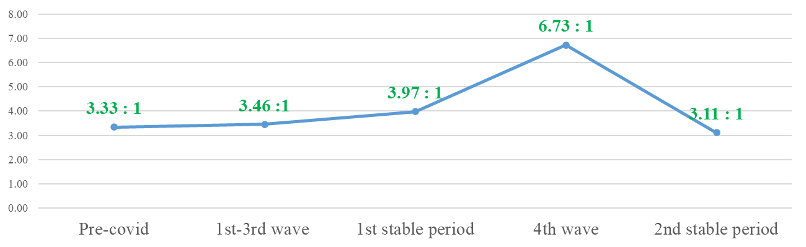
Figure 2. Social Return on Investment (SROI) ratio in different COVID periods
Notes. SROI ratio represent how many units of output generated by 1 unit of resource. For example, 3:1 represents 1 unit of input generates 3 units of outputs.

Figure 3. Service resources inputs and outputs per month in different COVID periods (HKD in millions)
