List of award-winning HKU technologies at the International Exhibition of Invention Geneva 2019
PI | Department | Project Title and Short Description | Exhibition Photo | Award Received at IEIG 2019
Prof Chuyang Tang | Civil Engineering | Portable Water Filter – High throughput filter product that can efficiently remove heavy metals (such as lead, cadmium, chromium and nickel) and microorganisms from contaminated waters. | 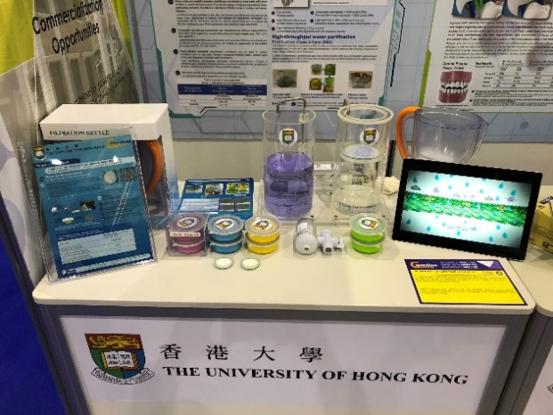 | Gold Medal
Prof LJ Jin & Dr TC Ng | Dentistry | Toothbrush – Toothbrush designed to target all dental surfaces in particular the inter-dental, retromolar and sub-gumline niches, so called the “dead-corners” where other toothbrushes are difficult to clean up. | 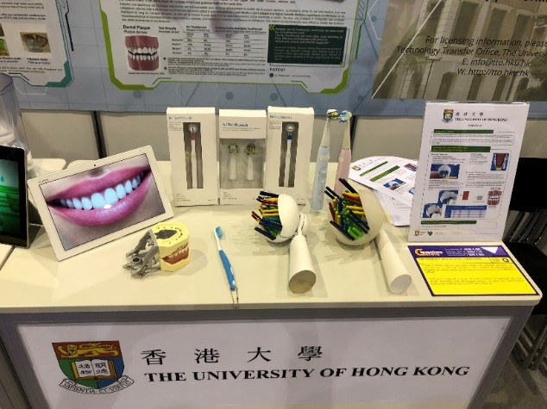 | Gold Medal
Prof XU Aimin | Medicine | Methods and Compositions for Use of Neutrophil Elastase and Proteinase 3 as Diagnostic Biomarkers – Method for risk predication and accurate diagnosis of autoimmune diabetes by measuring enzymatic activities and protein concentrations of neurophil elastase (NE) and proteinase 3 (PR3) in human plasma. | 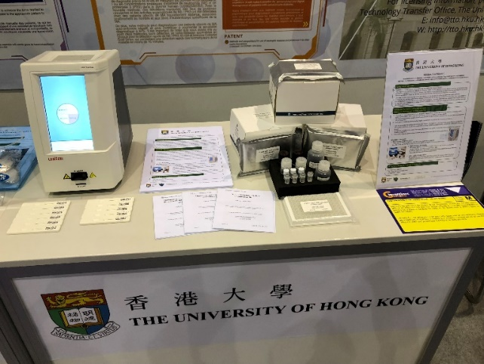 | Gold Medal
Dr. El-Nezami Hani | School of Biological Sciences | A novel probiotic mixture “Prohep” for treatment of hepatocellular carcinoma – Probiotic composition named “Prohep” that have potential therapeutic effects on Hepatocellular carcinoma. | 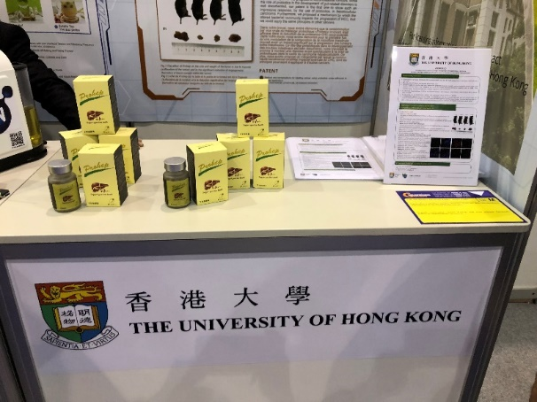 | Gold Medal
Prof Dennis Leung | Mechanical Engineering | Paper Battery – Flexible primary battery using aluminum as fuel. It is environmentally friendly, light-weight and flexible for enabling new kind of applications such as wearable and sensor technology | 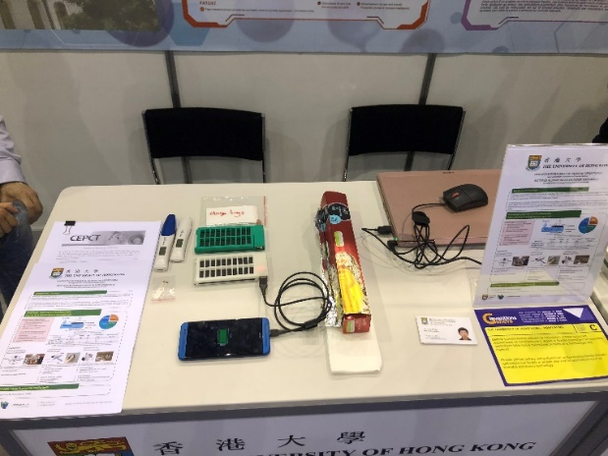 | Silver Medal
Dr HU Yong | Orthopaedics and Traumatology | Soft Robotic Glove for Rehabilitation – Soft robot hand for neutral rehabilitation of degenerative neurological diseases and strokes | 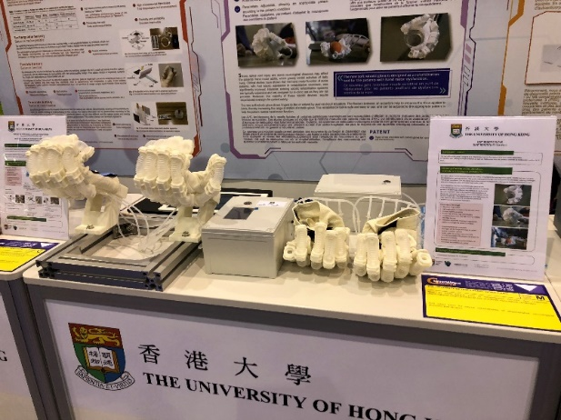 | Silver Medal
Dr Anderson Shum | Mechanical Engineering | Project ADEN: Affordable Automated Diversified Encapsulation – Encapsulation machine for making edible bubbles with different ingredients for archiving a wide variety of textures and tastes. | 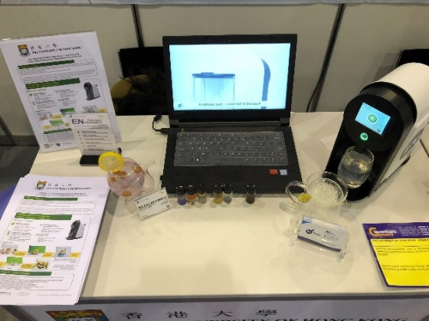 | Silver Medal

List of award-winning projects entered by HKU spinoff company, research collaborator and partner that are based on HKU technologies
Exhibiting Partner | PI | Department | Project Title | Photos | Award Received at IEIG 2019
Flectrode Ltd  (a HKU Spinoff company) | Dr Wendi Li | Mechanical Engineering | Transparent Conducting Film – embedded metal mesh transparent conductive film for emerging electronics | 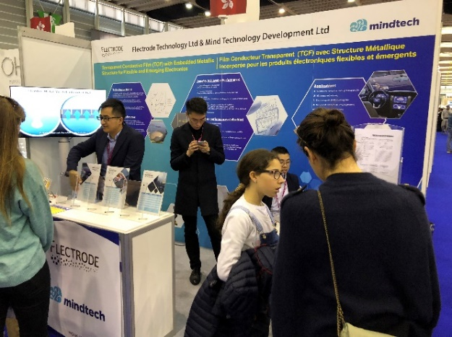 | Gold Medal with the Congratulations of Jury
Logistics and Supply-Chain MultiTech R&D Center (LSCM) | Dr Henry Lau | Industrial and Manufacturing Systems Engineering | The Real Virtuality for Aircraft Inspection (ReVAI) Training System – An immersive VR empowered training system for cost effective and authentic aircraft maintenance operation training and performance qualification. | 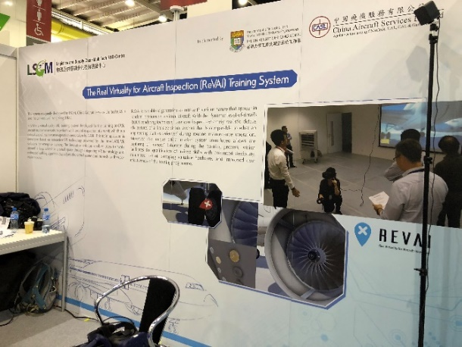 | Silver Medal
St Paul’s Primary Catholic School | Dr Vincent Tam | Electrical and Electronic Engineering | SmartEat – SmartEat education app helps kids in diet planning & prevent obesity by turning lunch visual content to nutritional values | 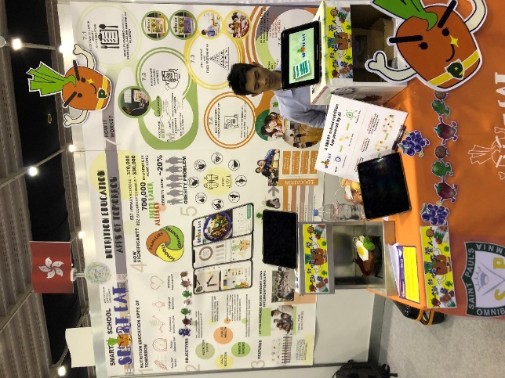 | Silver Medal

