Photos on display

Mass Transit Railway 地下鐵路

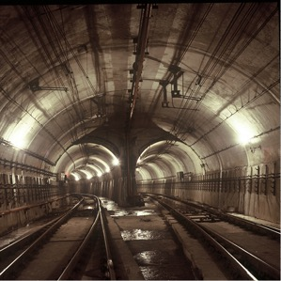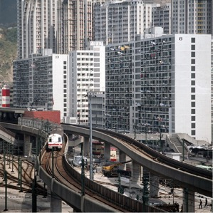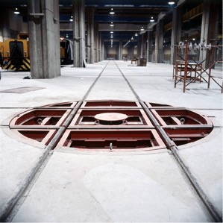

Hong Kong’s unique geology and urban density necessitated innovative methods to house, maintain, and operate the MTR system. Shown here are a few critical spaces within the initial MTR system in Kowloon that are hidden from plain view.
香港獨特的地質條件與城市密度需要創新的方法建設、維護以及運營地鐵系統。圖中顯示地鐵早期系統九龍部分不常見到的重要空間。

(from left, 左起)
- MTR Crossover Tunnel, 1979 地鐵交叉隧道，1979年
- Overhead section of the MTR at Kowloon, approaching Kowloon Bay Station, 1979
通往九龍灣站的架空地鐵軌道，1979年
- A turntable in Kowloon Bay Depot to enable carriages to be turned round to face the opposite direction, 1979 九龍灣車廠用於調轉列車方向的轉車台，1979年

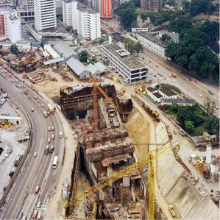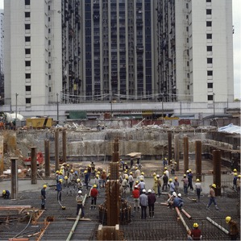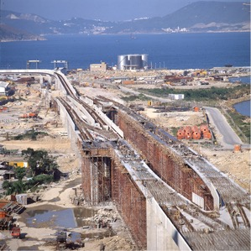

The Island Line was the second MTR line completed in Hong Kong. Admiralty station was one of the first stations opened on Hong Kong island is an important interchange between the Island Line and the Tsuen Wan Line. The massive scale of construction in Hong Kong’s landscape was demonstrated by the large structures below and above ground in the following photographs.
港島線是香港第二條地鐵線。金鐘站是港島其中一個最早開放車站，也是港島線與荃灣線的轉車站。下列的照片中的大型結構顯示了改變香港城市景觀基建工程的巨大規模。

(from left, 左起)
- Admiralty Station under construction, 1977 施工中的金鐘站，1977年
- MTR Island Line under construction, 1984施工中的地鐵港島線，1984年
- MTR in Chai Wan under construction, 1987 施工中的地鐵灣仔段，1987年

Highways and Tunnels 公路與隧道

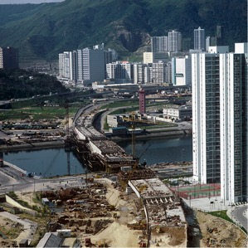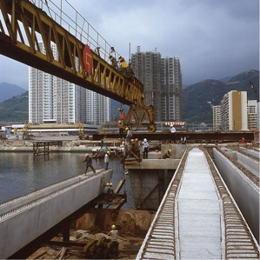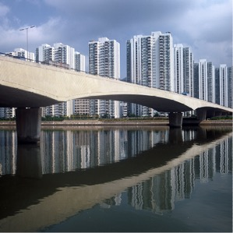

The mass construction of roadways in the 1970-80s enabled new town developments like Shatin to flourish. Constructed shortly after critical road segments such as the Cross Harbour Tunnel and the Lion Rock Tunnel, Shatin is well connected to the rest of the territory and currently houses a population of over 630 thousand.
1970至1980年代的大型道路建設工程令到沙田等新市鎮的蓬勃發展。沙田的發展緊隨紅磡海底隧道以及獅子山隧道等重大道路工程，如今沙田交通網絡四通八達，居住超過63萬人口。

(from left, 左起)
- Shatin Bridge in progress, 1986 沙田橋施工進度，1986年
- Shatin Bridge under construction, 1982 施工中的沙田橋，1982年
- Shatin Bridge completed, 1987 落成後的沙田橋，1987年

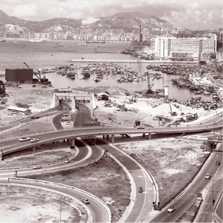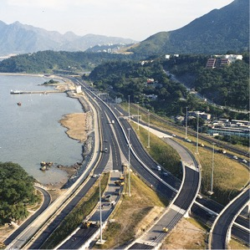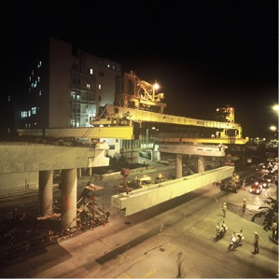

The Cross Harbour Tunnel is the first road connection between Hong Kong Island and the Kowloon Peninsula completed in 1972. Despite concerns regarding high toll fees, the tunnel quickly became one of the most important crossings in the city. It is also a critical component of Route 1 that connects Aberdeen to Shatin.
1972年完成的紅磡隧道是港島與九龍半島之間的第一個道路連接。儘管當時有人認為隧道費太貴，但是紅隧很快成為城市交通不可缺少的一部分。

(from left, 左起)
- Approach Roads to the first Cross Harbour Tunnel in Causeway Bay, 1972 銅鑼灣通往紅磡隧道的道路，1972年
- Construction of the new trunk road from Shatin to Tai Po, 1986 沙田至大埔的主幹道工程，1986年
- Night time lifting of prestressed concrete bridge beams for the Cornwall Street flyover, Date Unknown 夜間吊裝歌和老街跳橋預應力混凝土樑，日期未確定
Electricity Networks 電力設施

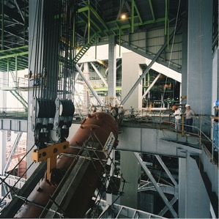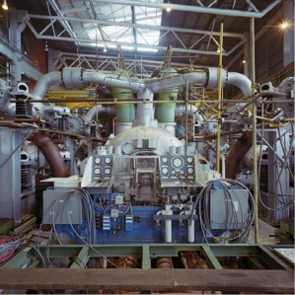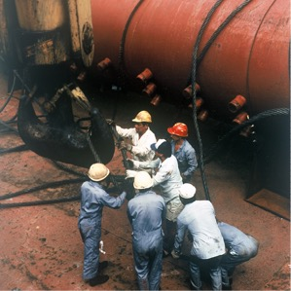
At the time of completion in 1990, Castle Peak Power Station complex was the largest in South East Asia, including its iconic chimney which was the tallest reinforced concrete structure in Hong Kong. The installation of large-scale equipment was a challenge for the construction crews.
青山發電廠1990年落成時是東南亞最大的發電廠，其標誌性的煙囪也是當時香港最高的混凝土構築物。大型設備的組裝是工程團隊的一項重大挑戰。

(from left, 左起)
- Lifting the steam drum for boiler construction at Castle Peak ‘B’ Power Station. The drum had to be lifted inclined to get it up through the rectangular boiler frame. 1984青山發電廠B廠鍋爐工程中吊升氣鼓。氣鼓須要吊升斜置以通過鍋爐的矩形框架，1984年
- Castle Peak 'B' Station - Turbine Hall 1984 青山發電廠B廠——汽輪機工作艙，1984年
- Preparing to lift the steam drum for Castle Peak 'B" Power Station boiler erection 1984 準備吊升氣鼓以架設青山發電廠B廠鍋爐，1984年

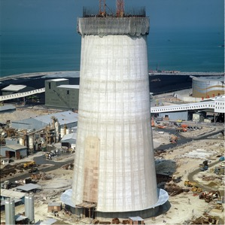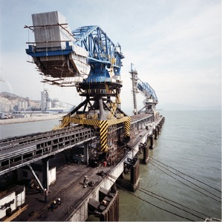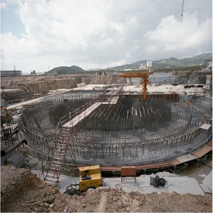
Due to the global oil crisis in the late 1970s, CLP decided to install multi-fuel generators, including oil, coal, and natural gas in order to adapt to fluctuating fuel costs at Castle Peak. Daya Bay Nucelar Plant is an important supplement for the rising electricity needs of Hong Kong.
七十年代後期的全球石油危機後，中電決定安裝多組燃料發電機，包括石油，煤炭和天然氣，應對燃料成本的波動。 大亞灣核電廠對香港日益增長的用電需求重要補充。

(from left, 左起)
- Castle Peak Power Station chimney under construction showing the rising shutter for concreting, 1984 建設中的青山發電廠煙囪，圖中可見澆築混凝土的圍板。1984年
- Jetty and Crane for unloading coal at Castle Peak Power Stations, Tuen Mun, 1984 青山發電廠煤炭卸貨碼頭和吊臂，屯門，1984年
- Construction of the foundation slab for the nuclear reactor at Daya Bay Power Station, Guangdong Province, China, 1987 大亞灣核電廠核子反應堆基座建設工程，中國廣東省，1987年
Water Works 供水系統

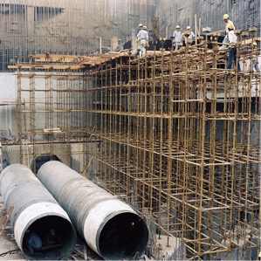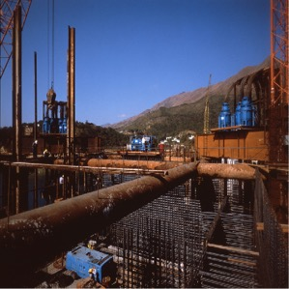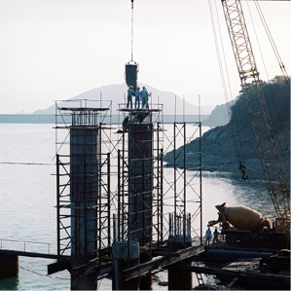

The Tai Mei Tuk “B” Pumping Station began construction in 1982 in order to link Plover Cove with the newly completed High Island Reservoir. This new linkage was one of the critical infrastructural upgrades to manage large quantities of freshwater imported from Guangdong Province.
大尾篤抽水站B於1982年動工，連接船灣淡水湖與新落成的萬宜水庫。這一新的連接設施是為管理從廣東入口大量淡水而建設的其中一項重要基建升級工程。

(from left, 左起)
- Laying of water pipes from the Tai Mei Tuk Pumping Station, Plover Cove Reservoir, 1985 從船灣淡水湖大尾篤抽水站鋪設水管，1985年
- Construction of Tai Mei Tuk Pumping Station, 1985 大尾篤抽水站建設工程，1985年
- Construction of columns for the access bridge to the Tai Mei Tuk Pumping Station, Plover Cove Reservoir, 1985 通往船灣淡水湖大尾篤抽水站的連接橋橋墩建設工程，1985年

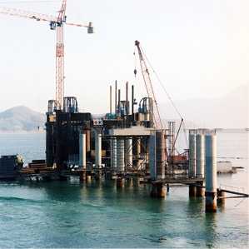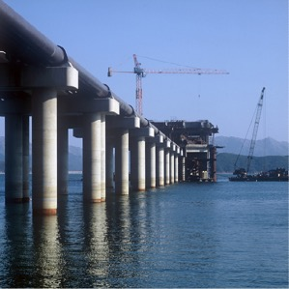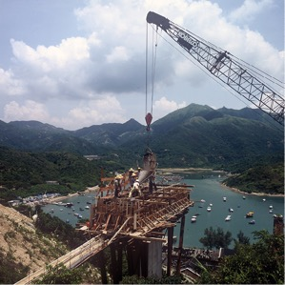

Hong Kong’s hilly terrain and unique geology is challenging for the storage of water and processes of construction. The naturalistic scenery of these reservoirs requires significant landscape maintenance to protect the water sources and environmentally sensitive approaches to additional construction.
香港的山地地形與獨特的地質條件對淡水儲蓄與工程進度構成挑戰。水塘的自然景觀需要特別的維護措施以保護水源，新建工程也需要顧及對環境影響。

(from left, 左起)
- Tai Mei Tuk ‘B’ pumping station and access bridge, 1985 大尾篤抽水站B以及連接橋，1985年
- Access bridge to the Tai Mei Tuk Pumping Station nearing completion, 1985 通往大尾篤抽水站的連接橋將近落成，1985年
- Road Concreting near Tai Tam Reservoir, 1985 大潭水塘附近道路混凝土澆築，1985年

