Rank  排名 | Abundance  數量 | Scientific name  學名 | Chinese Name  中文名 | English Name  英文名 | AFCD Assessment  漁護署評估
1 | 499 | Pseudozizeeria maha | 酢漿灰蝶 | Pale Grass Blue | VC
2 | 348 | Zizina otis | 毛眼灰蝶 | Lesser Grass Blue | C
3 | 339 | Catopsilia sp. | 遷粉蝶屬 | Emigrants | C / VC
4 | 92 | Papilio polytes | 玉帶鳳蝶 | Common Mormon | VC
5 | 36 | Pieris canidia | 東方菜粉蝶 | Indian Cabbage White | VC
5 | 36 | Chilades pandava | 曲紋紫灰蝶 | Plains Cupid | UC
5 | 36 | Elymnias hypermnestra | 翠袖鋸眼蝶 | Common Palmfly | C
6 | 33 | Hebomoia glauccipe | 鶴頂粉蝶 | Great Orange Tip | C
7 | 24 | Papilio memnon | 美鳳蝶 | Great Mormon | VC
8 | 21 | Papilio protenor | 藍鳳蝶 | Spangle | VC
8 | 21 | Eurema sp. | 黃粉蝶屬 |  | NA
9 | 12 | Hestina assimilis | 黑脈蛺蝶 | Red Ring Skirt | C
10 | 11 | Cupha erymanthis | 黃襟蛺蝶 | Rustic | VC
10 | 11 | Papilio helenus | 玉斑鳳蝶 | Red Helen | VC
11 | 10 | Hypolimnas bolina | 幻紫斑蛺蝶 | Great Egg-fly | C
11 | 10 | Graphium agamemnon | 統帥青鳳蝶 | Tailed Jay | C
12 | 8 | Danaus genutia | 虎斑蝶 | Common Tiger | C
12 | 8 | Lampides boeticus | 亮灰蝶 | Long-tailed Blue | C
13 | 7 | Acytolepis puspa | 鈕灰蝶 | Common Hedge Blue | C
13 | 7 | Graphium sarpedon | 青鳳蝶 | Common Bluebottle | VC
14 | 6 | Neptis hylas | 中環蛺蝶 | Common Sailer | VC
14 | 6 | Papilio bianor | 碧鳳蝶 | Chinese Peacock | C
14 | 6 | Euthalia phemius | 尖翅翠蛺蝶 | White-edged Blue Baron | C
15 | 5 | Borbo cinnara | 秈弄蝶 | Formosan Swift | C
15 | 5 | Papilio clytia | 斑鳳蝶 | Common Mime | C
15 | 5 | Cyrestis thyodamas | 網絲蛺蝶 | Common Mapwing | C
15 | 5 | Ideopsis similis | 擬旖斑蝶 | Ceylon Blue Glassy Tiger | VC
16 | 4 | Graphium doson | 木蘭青鳳蝶 | Common Jay | C
16 | 4 | Euploea midamus | 藍點紫斑蝶 | Blue-spotted Crow | VC
16 | 4 | Papilio paris | 巴黎翠鳳蝶 | Paris Peacock | VC
17 | 3 | Ypthima baldus | 矍眼蝶 | Common Five-ring | VC
17 | 3 | Suastus gremius | 素弄蝶 | Indian Palm Bob | UC
17 | 3 | Abisara echerius | 蛇目褐蜆蝶 | Plum Judy | VC
17 | 3 | Mycalesis mineus | 小眉眼蝶 | Dark Brand Bush Brown | VC
17 | 3 | Delias pasithoe | 報喜斑粉蝶 | Red-base Jezebel | VC
17 | 3 | Iraota timoleon | 鐵木萊異灰蝶 | Silver Streak Blue | UC
18 | 2 | Parathyma sulpitia | 殘鍔線蛺蝶 | Five-dot Sergeant | C
18 | 2 | Argyreus hyperbius | 斐豹蛺蝶 | Indian Fritillary | C
18 | 2 | Athyma nefte | 相思帶蛺蝶 | Colour Sergeant | C
18 | 2 | Jamides alecto | 素雅灰蝶 | Metallic Cerulean | VR
19 | 1 | Tajuria cippus | 雙尾灰蝶 | Peacock Royal | R
19 | 1 | Jamides bochus | 雅灰蝶 | Dark Cerulean | C
19 | 1 | Pantoporia hordonia | 金蟠蛺蝶 | Common Lascar | UC
19 | 1 | Neptis clinia | 珂環蛺蝶 | Southern Sullied Sailer | C
19 | 1 | Catochrysops strabo | 咖灰蝶 | Forget-me-not | VR
19 | 1 | Charaxes bernardus | 白帶螯蛺蝶 | Tawny Rajah | C
19 | 1 | Tirumala limniace | 青斑蝶 | Blue Tiger | C
19 | 1 | Phaedyma columella | 柱菲蛺蝶 | Short-banded Sailer | C
19 | 1 | Euploea mulciber | 異型紫斑蝶 | Striped Blue Crow | UC
19 | 1 | Junonia iphita | 鉤翅眼蛺蝶 | Chocolate Pansy | C
19 | 1 | Deudorix epijarbas | 玳灰蝶 | Cornelian | R
VC : Very Common非常常見
C : Common常見
UC: Uncommon 不常見
R: 罕見 Rare
VR: 非常罕見 Very Rare
NA: Not available

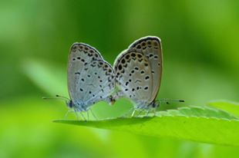 | 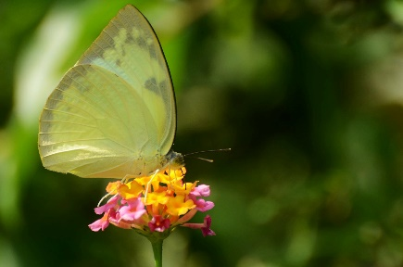 |  | 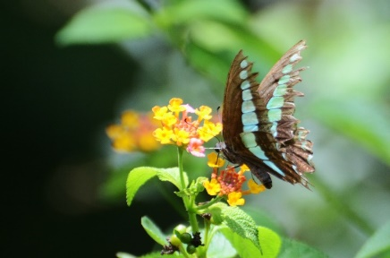
Pseudozizeeria maha  酢漿灰蝶  Pale Grass Blue | Catopsilia sp.  遷粉蝶屬  Emigrants | Papilio polytes  玉帶鳳蝶  Common Mormon | Graphium sarpedon  青鳳蝶  Common Bluebottle
 | 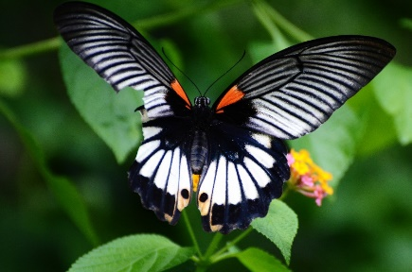 | 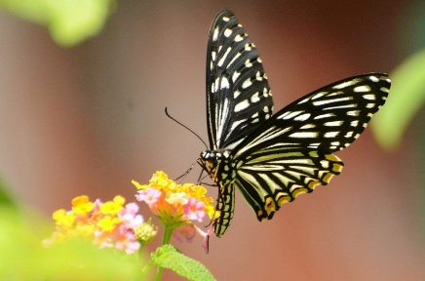 | 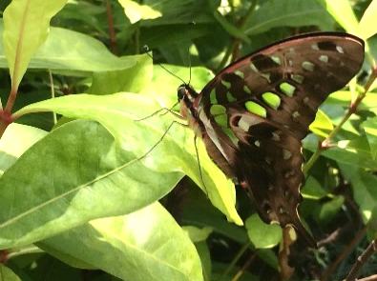
Papilio protenor  藍鳳蝶  Spangle | Papilio memnon  美鳳蝶  Great Mormon | Papilio clytia  斑鳳蝶  Common Mime | Graphium agamemnon  統帥青鳳蝶  Tailed Jay
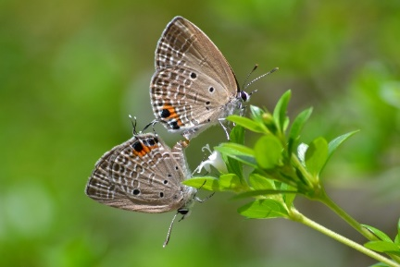 | 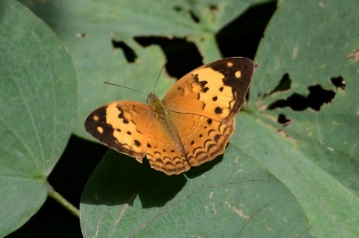 | 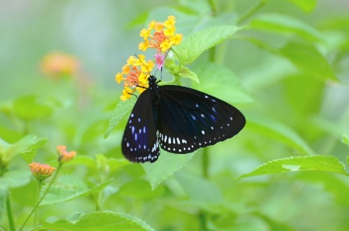 | 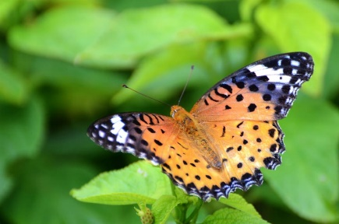
Chilades pandava  曲紋紫灰蝶  Plains Cupid | Cupha erymanthis  黃襟蛺蝶  Rustic | Euploea midamus  藍點紫斑蝶  Blue-spotted Crow | Argyreus hyperbius  斐豹蛺蝶  Indian Fritillary
Ideopsis similis  擬旖斑蝶  Ceylon Blue Glassy Tiger | Charaxes bernardus  白帶螯蛺蝶  Tawny Rajah | Mycalesis mineus  小眉眼蝶  Dark Brand Bush Brown | Jamides alecto  素雅灰蝶  Metallic Cerulean

