Figures and captions:
“Light Pollution Field Trip”
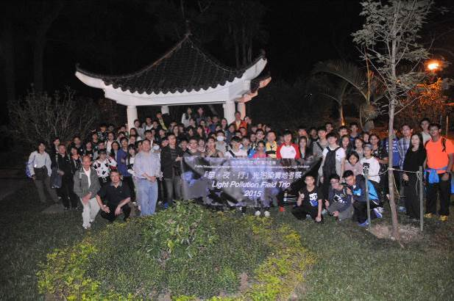  Figure 1: Firefly viewing in Tai Po Kau Nature Reserve | 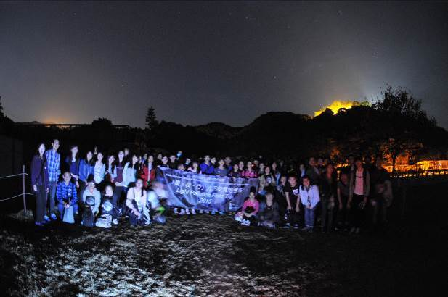  Figure 2: Stargazing in Astropark at Sai Kung
“Light Pollution Research Competition 2015-16”
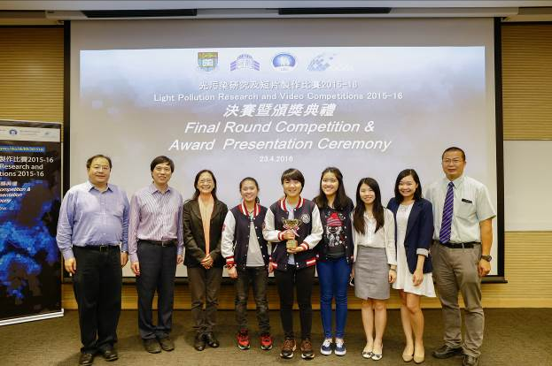  Figure 3: Champion - Marymount Secondary School (topic: Light pollution and Ecosystem)  (from left to right: Dr Jason Pun, Mr Robert Leung, Prof Vivian Taam Wong, Lilian Ng, Clare Cheng, Emily Liu, Miss Jane Chung, Miss Vicky Lee, Principal Kwok Chi Tai) | 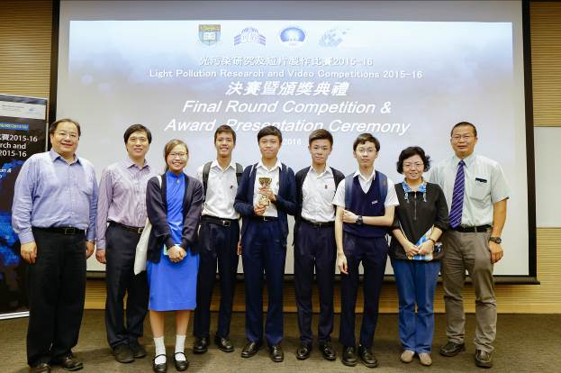  Figure 4: First runner up - Sheng Kung Hui Tang Shiu Kin Secondary School (topic: Festival Lights: Celebration or Pollution?)  (from left to right: Dr Jason Pun, Mr Robert Leung, Chau Tsz Wai, Law Kam Hin, Chung Cheuk Nam, Wu Kam To, Edward Lee Tsz Hin, Miss Chau Yuk Lin, Principal Kwok Chi Tai)
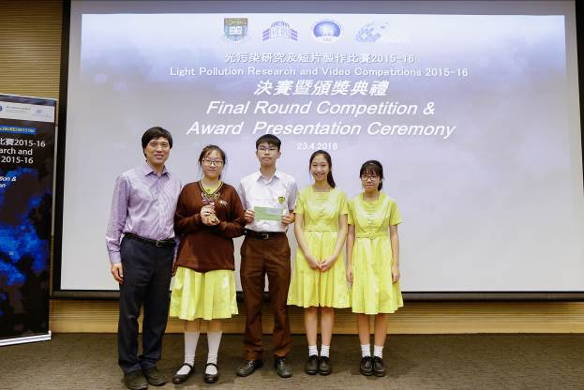

Figure 5: Second runner up - Buddhist Sin Tak College (topic: Light Pollution in Hong Kong)
(from left to right: Mr Robert Leung, Chan Xiao Jun, Wong Pui Ho, Li Yee Mei, Maggie Tsai Ching Man)

“Light Pollution Video Competition 2015-16”
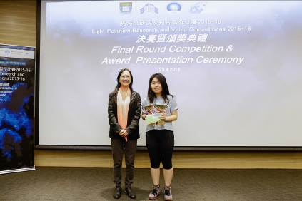  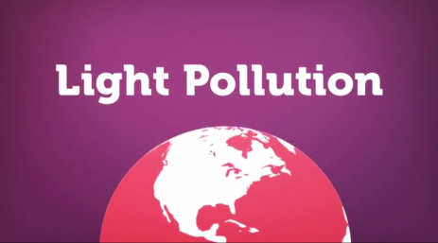  Figure 6: Champion & Youth Prize - Crystal Leung Yu Hang (entry: To Cast a Bright Light)  (from left to right: Prof Vivian Taam Wong, Crystal Leung Yu Hang) | 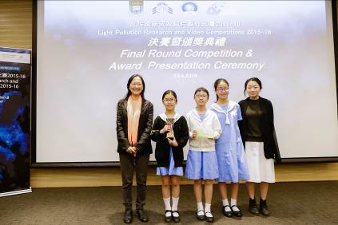  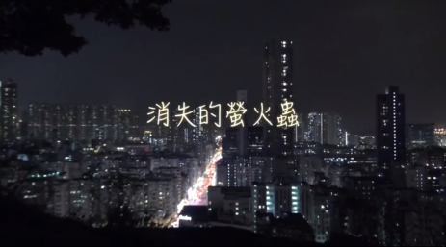  Figure 7: First runner up - St. Bonaventure Catholic Primary School (entry: The Missing Fireflies)  (from left to right: Prof Vivian Taam Wong, Ng Wing Tung, Chu Yin Shan, Chau Ka Yiu, Miss Edvanna Wong) | 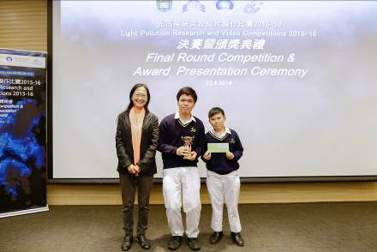  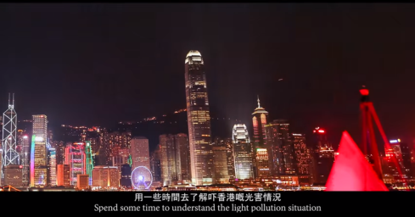  Figure 8: Second runner up - Salesian English School (entry: My Hong Kong · Light Pollution)  (from left to right: Prof Vivian Taam Wong, Paul Chan Lok He, Jonathan Wai Yin Long)
“Light Pollution Research Competition 2015-16” &“Light Pollution Video Competition 2015-16”
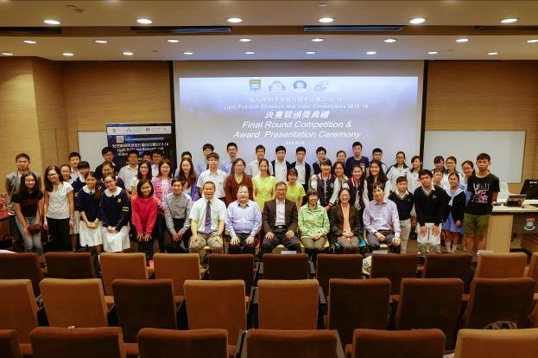

Figure 9: Group photo

