**馬料水渡輪碼頭位置圖**

**Location of Ma Liu Shui Public Pier**

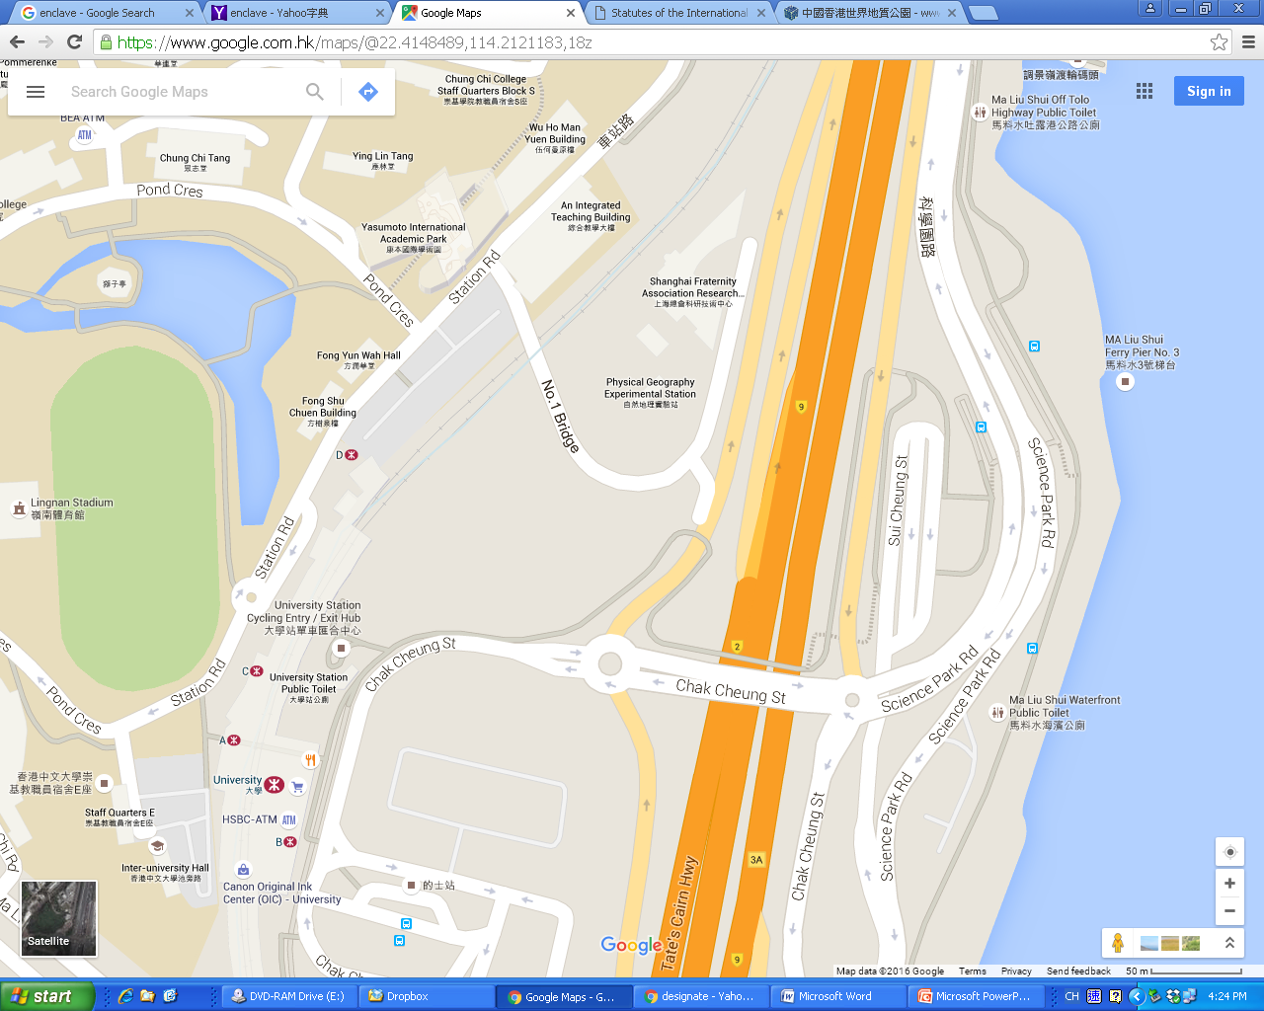

Ma Liu Shui Public Pier No.2

[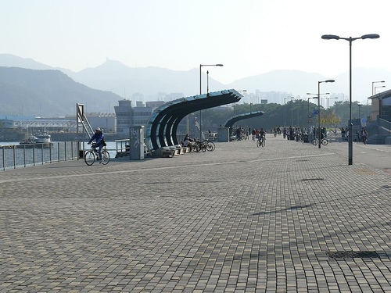](http://www.google.com.hk/url?sa=i&rct=j&q=&esrc=s&source=images&cd=&cad=rja&uact=8&ved=0ahUKEwiU5-nqtfvKAhUSB44KHee_CogQjRwIBw&url=http://blog.xuite.net/hkoutlander/hkblog/173959829-%E5%85%83%E6%97%A6%E6%97%A5%2B%E5%9A%9F%E5%92%97%2B%E9%A6%AC%E6%96%99%E6%B0%B4%2B%E8%A1%8C%E5%90%93%E6%B5%B7%E9%82%8A~%2BMa%2BLiu%2BShui%2BFerry%2BPier,%2BTolo%2BHarbour,%2BShatin&psig=AFQjCNFoTHL-LpaUncYXQLxwfBjdcSk6OQ&ust=1455682404963289)

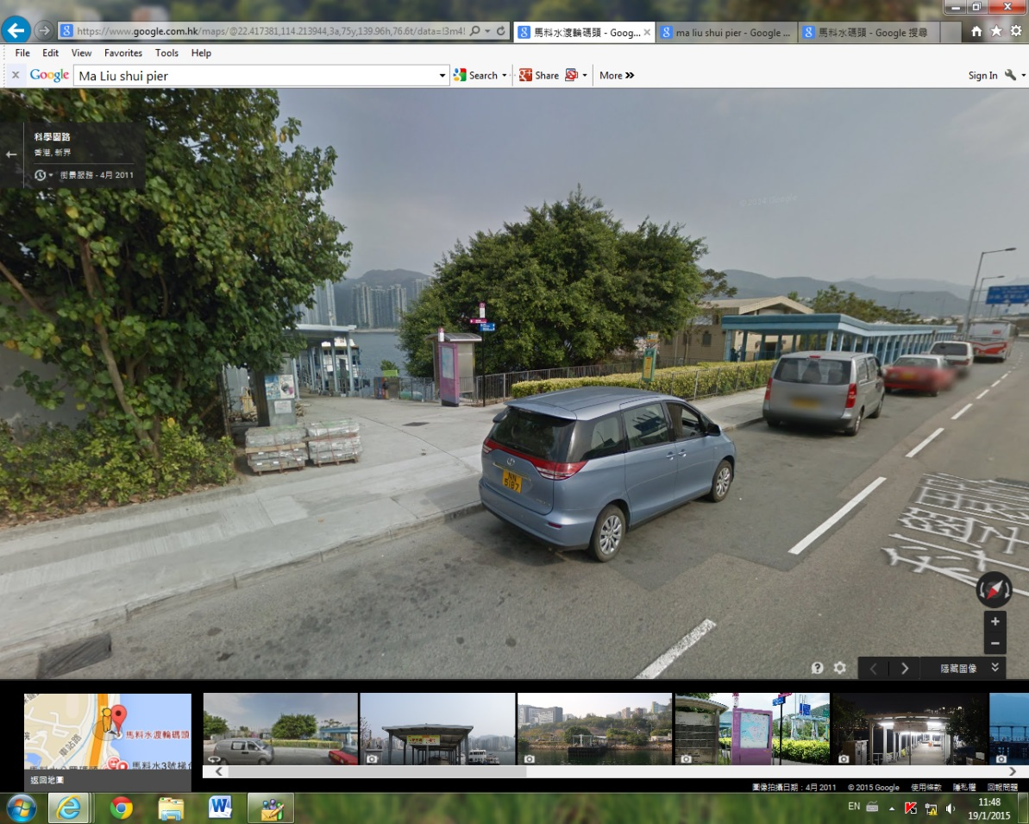

由大學站步行

約10分鐘

10-min walk from University Station