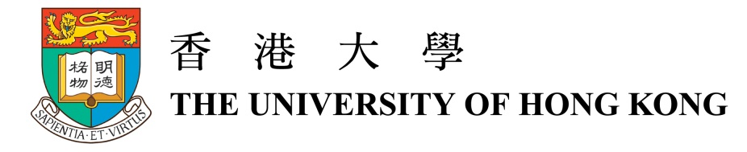

Professor Chen Guanhua
Head of Department of Chemistry, Faculty of Science
The University of Hong Kong

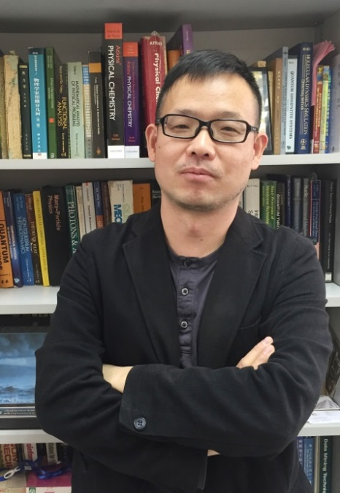
Professor Chen Guanhua is a Professor of Department of Chemistry, Faculty of Science, The University of Hong Kong. He received a Bachelor of Science degree from Fudan University in 1986, and passed China-US Physics Examination and Application (CUSPEA) program as the Co-1st place. Then he went to California Institute of Technology (Caltech) for further study and received his PhD degree in 1992. After postdoctoral training in University of Rochester, he joined the Department of Chemistry at the University of Hong Kong in 1996 as an assistant professor. In 2010, he became the Head of the Department of Chemistry.

His current research interests focus on linear-scaling quantum computation methods of excited states, first principles methods for open systems, multiscale quantum mechanics/electro-magnetics (QM/EM) method for device simulations, and application of neural network approaches for quantum calculations. Recently, Professor Chen is devoted to the study of emerging electronics and applied the developed methods to simulate and explore emerging nano-electronics and semiconductor materials, which can bridge the gap between quantum mechanics method and circuit simulation and make it possible to predict the electronic performance starting from atomic simulations. Due to his ground breaking work in these fields, Professor Chen was elected as the Fellow of Royal Chemical Society in 2011 and the Fellow of American Physical Society in 2014.

Awards
- Croucher Senior Research Fellowship (2016)
- Fellow of American Physical Society (2014)
- Fellow of Royal Chemical Society (2011)
- Outstanding Young Scholar Award, NSFC (2009-2010)
- National Natural Science Award (First Class), Education Ministry of China (2008)
- Outstanding Young Researcher Award 2001-2002, The University of Hong Kong
- Co-1st place in China-US Physics Examination and Application (CUSPEA) program (1985)

Professional Services / Standing
- Vice-President of Hong Kong Institution of Science (2013-2015)
- Associate Editor, European Physical Journal B (2012-2016)

Honorable positions
- Guest Professor, University of Science and Technology of China (2005-)
- Senior Visiting Scholar, Tsinghua University (2005-2011)
- Senior Visiting Scholar, Fudan University (2003-2005)
- Adjunct Professor, Dalian Institute of Chemical Physics (2002-2006)
- Adjunct Professor, Zhongshan University (2002-2005)
- Guest Professor, Northeast Normal University(1999-)

