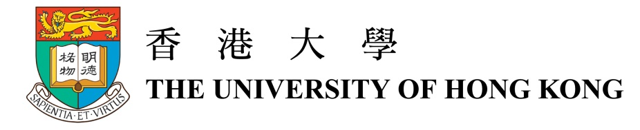

2016 Croucher Innovation Award

Dr Au-Yeung Ho Yu
Assistant Professor of Department of Chemistry, Faculty of Science
the University of Hong Kong

Biography
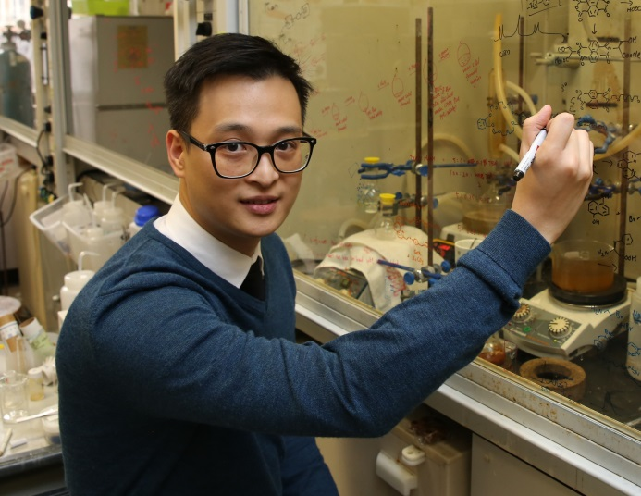
Dr Au-Yeung Ho Yu is currently an Assistant Professor of the Department of Chemistry at the University of Hong Kong. He obtained his BSc (1st Hons) and MPhil degrees in Chemistry in 2004 and 2006 respectively from the Chinese University of Hong Kong, and graduated with a PhD degree from the University of Cambridge in 2010. He worked as a postdoctoral researcher at the University of California, Berkeley in 2011-2013. He joined the University of Hong Kong in September 2013.

His main research interest is in the area of supramolecular chemistry and molecular recognition. He is interested in understanding how molecules recognise and interact with each other, exploiting molecular interactions in the self-assembly of complex structures, and creating functional materials from molecular assembly and recognition. In particular, his group is now exploring different assembly strategies for the assembly of topologically complex molecules such as catenanes with multiple interlocked macrocycles, as well as developing systems that can selectively recognise and detect small organic molecules in the complex biological environment.

One specific project in his group concerns the molecular recognition of catecholamine. Catecholamine, such as dopamine, is a class of small molecule neurotransmitter that transmits nervous signal in the nervous system. Recognition system that can selectively capture and report levels of catecholamine in the complex biological environment could lead to different bioanalytical tools to aid the study of these important biomolecules. For example, a catecholamine specific fluorescent probe can help trace the changes of the level of the small molecule in health and disease states, providing valuable information on the role of the neurotransmitter in different neurodegenerative diseases. Another project in his group is about the self-assembly of complex catenanes, which are mechanically interlocked chain at the molecular level. Due to the mechanical linkages in these interlocked rings, the catenanes possess unusual mechanical strength and flexibility which could be exploited as new types of molecular materials.

Dr Au-Yeung received the Croucher Foundation Scholarship and Croucher Foundation Fellowship for his PhD and postdoctoral studies respectively. He has also recently been awarded the Croucher Innovation Award and the Thieme Chemistry Journals Award 2016.

